Ideation Phase Empathize & Discover

|  |  |
| --- | --- |
| Date | 9 February 2025 |
| Team ID | SWTID1744456946 |
| Project Name | MediBoard |
| Maximum Marks | 4 Marks |

# Empathy Map Canvas:

An empathy map is a simple, easy-to-digest visual that captures knowledge about a user’s behaviours and attitudes.

It is a useful tool to helps teams better understand their users.

Creating an effective solution requires understanding the true problem and the person who is experiencing it. The exercise of creating the map helps participants consider things from the user’s perspective along with his or her goals and challenges.

We’ve created empathy maps for the two primary user types of our "MediBoard" application:

# Empathy Map: Patient Persona

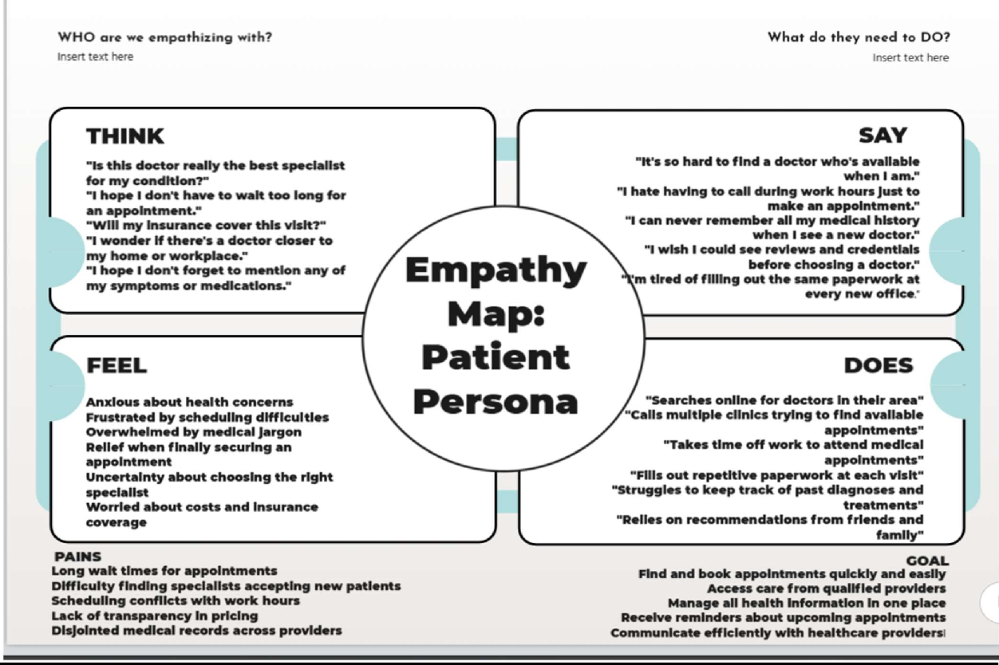

**Empathy Map: Doctor Persona**

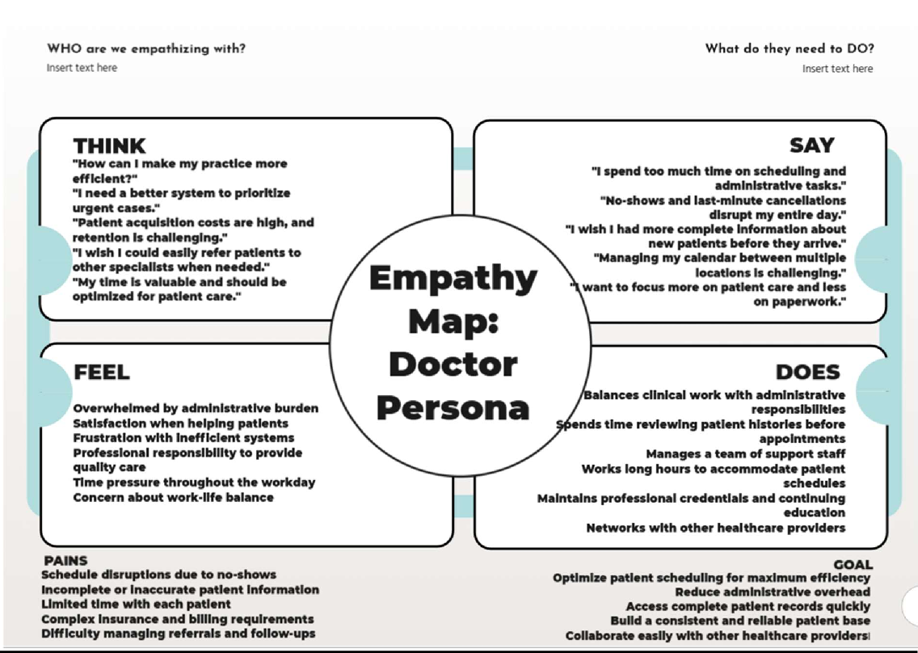

These empathy maps provide insight into the needs, motivations, and pain points of both patients and doctors, helping to guide the development of our "MediBoard" MERN stack application with features that address real user needs.